Transmission range=1000m
UE: number of users | First-hop Bandwidth:  MHZ | Second-hop  right-side  Bandwidth:  MHZ | Second-hop  left-side  Bandwidth:  MHZ | Successful transmission ratio
1800 | 10 | x | x | 56%
1800 | 10 | 10 multiplex |  | 99.82%
1800 | 10 | 5 | 5 | 95.90%
1800 | 5 | x | x | 39.67%
1800 | 5 | 5 multiplex |  | 77.72%
1800 | 6 | x | x | 45.74%
1800 | 6 | 4 multiplex |  | 77.31%
1800 | 8 | x | x | 54.26%
1800 | 8 | 2 multiplex |  | 70.90%
1200 | 5 | x | x | 54.26%
1200 | 5 | 5 multiplex |  | 100%

Observation:
- if the overall bandwidth is fixed (e.g., 10 MHz), the packet reception ratio (PRR) is increased by applying the two hops V2V communication. However, the E2E latency might be increased for the receivers which receive the packets from the 2nd hop only. The tendency for PRR performance is that, a better performance can be experienced if the two hops have the resource in a more balanced way (there might be a mathematical equation for this phenomenon). From the mathematical analysis, I can see that if the interference power is much smaller than the noise power (this can also be a consideration to control the transmission power in a way that the interference power is much smaller than the noise power), the resource should be split equally between the first and the second hop. If the interference is not much smaller than the noise power, then we need to calculate the fraction of resource allocation based on the numerical estimation algorithm.
- A comparison between three values can be given (10MHz for the first hop, 5+5 MHz (optimal solution) for the first and the second hops, and 8+2 MHz for the first and the second hops).(graph)

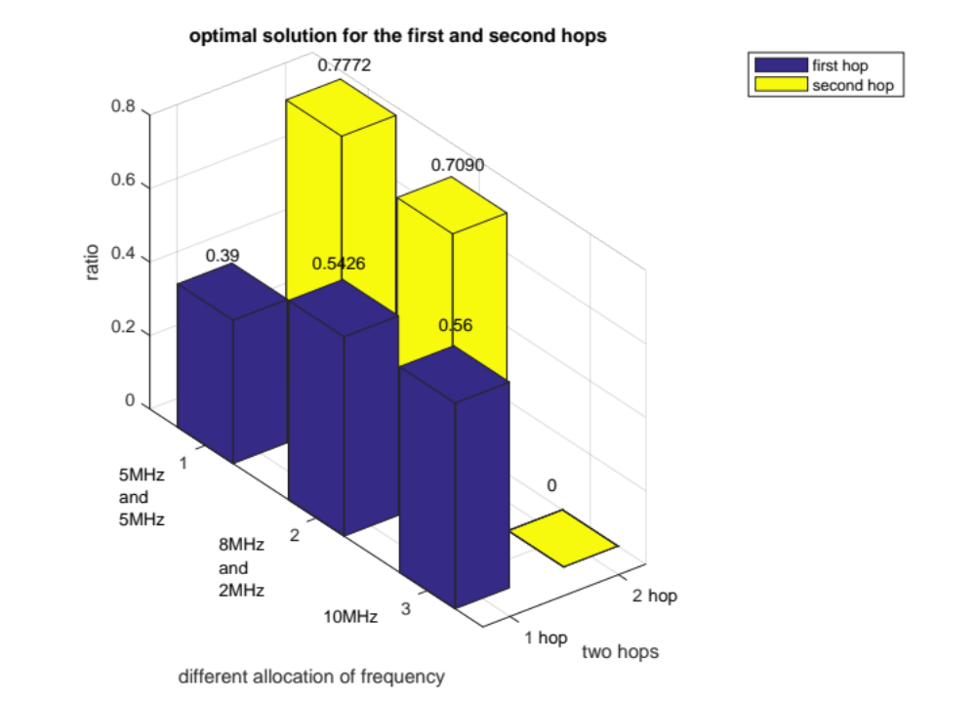

- Different bandwidth in first hop
Transmission range=1000m
UE: number of users | First-hop Bandwidth:  MHZ | Successful transmission ratio
1800 | 10 | 56%
1800 | 8 | 54.26%
1800 | 6 | 45.74%
1800 | 5 | 39.67%
1200 | 5 | 54.26%
1200 | 6 | 57.54%
1200 | 8 | 67.02%
1200 | 10 | 71.28%

Observation:
- We can plot again the same figure but now change the number of vehicles to be 1200.

- 20MHZ used in both first-hop and second-hop
Transmission range=1000m
UE: number of users | First-hop Bandwidth:  MHZ | Second-hop  right-side  Bandwidth:  MHZ | Second-hop  left-side  Bandwidth:  MHZ | Successful transmission ratio
1800 | 10 | 5 | 5 | 95.90%
1800 | 10 | 10 multiplex |  | 99.82%

3.10MHZ used in both first-hop and second-hop
Transmission range=1000m
UE: number of users | First-hop Bandwidth:  MHZ | Second-hop  right-side  Bandwidth:  MHZ | Second-hop  left-side  Bandwidth:  MHZ | Successful transmission ratio
1800 | 5 | 5 multiplex |  | 77.72%
1800 | 6 | 4 multiplex |  | 77.31%  84.46%
1800 | 8 | 2 multiplex |  | 70.90%
1200 | 5 | 5 multiplex |  | 100%
1200 | 6 | 4 multiplex |  | 99.82%
1200 | 8 | 2 multiplex |  | 84.93%

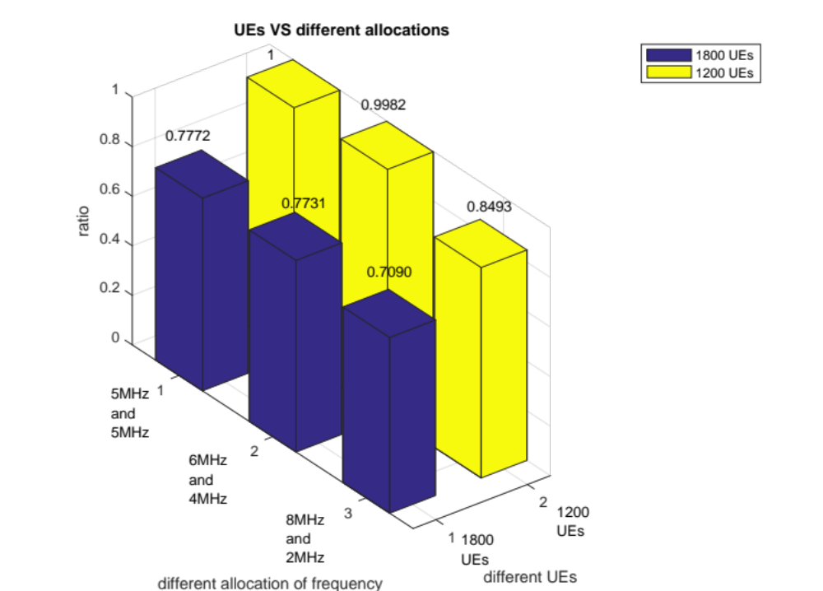
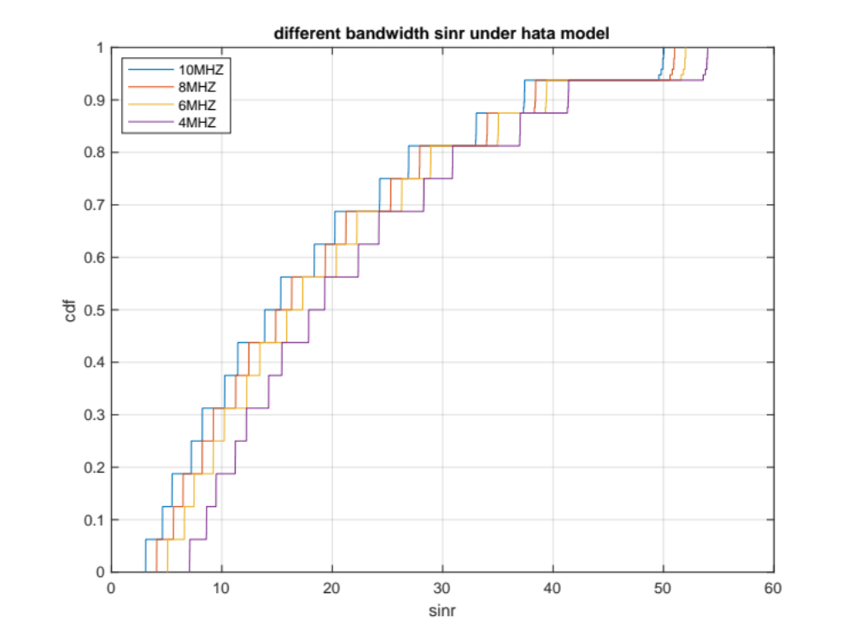
$$SINR=\frac{P_{Tx}∙h_{Rt}}{\sum{P_{Tx^{'}}}∙h_{Rt^{'}}+σ^{2}}$$

$$σ^{2}=PSD×BW$$
$P_{Tx}∙h_{Rt}$: received signal power.
$\sum{P_{Tx^{'}}}∙h_{Rt^{'}}$: interference.
$σ^{2}$: noise power.
BW: bandwidth.
When BW decreased, $σ^{2}$ is decreased. Then SINR is increased.
SINR is increased with decreased BW.
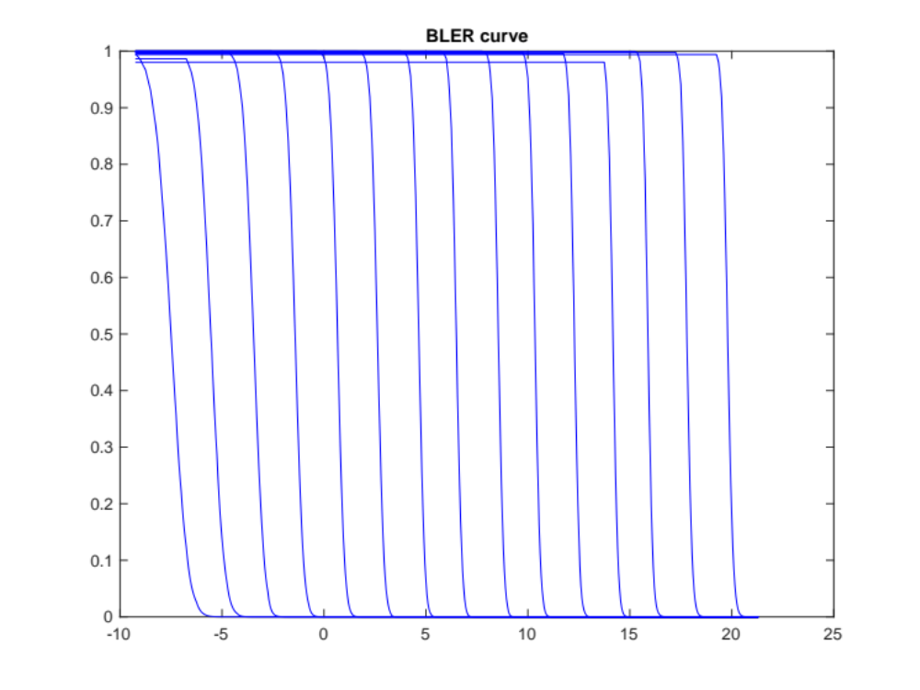
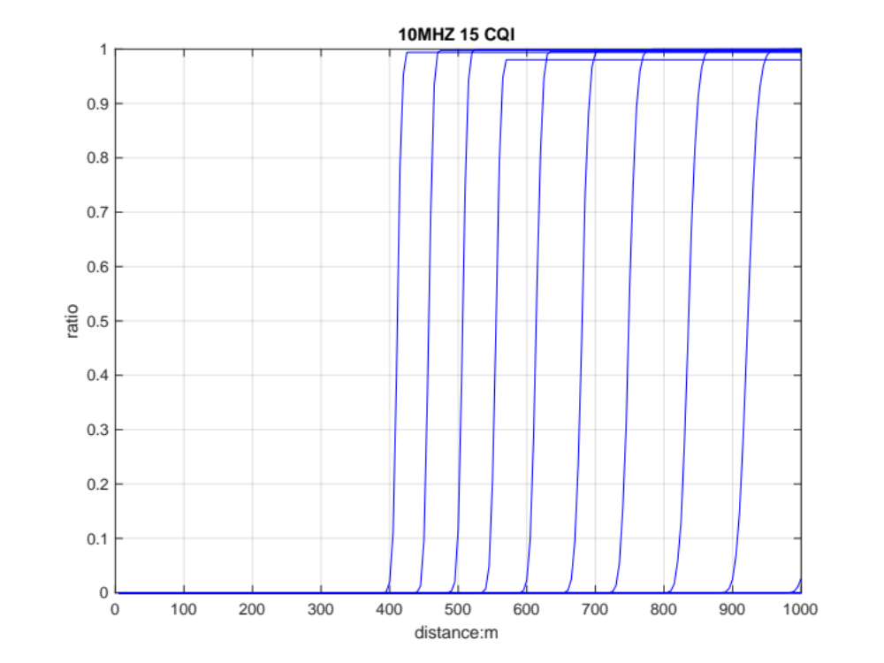
With the increased CQI, the threshold SINR is increased. SINR increased with the decreased distance.

